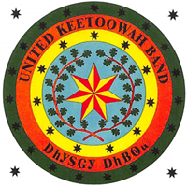
Physical: 18263 W. Keetoowah Circle Office: (918)871-2770
Tahlequah, OK 74464 Fax: (918)414-4070
Mailing: PO Box 746
Tahlequah, OK 74464

United Keetoowah Band of Cherokees Office of the Tax Commission

Authorization to Add Tribal Citizen

Date: ______________

I/We, _____________________________, the secured party or duty
Authorized representative of such party do hereby authorize
___________________________________, a citizen of the United Keetoowah Band of the Cherokee Indians in Oklahoma, to be included on the following vehicle:

Year:____________ Make:_________________Model:____________________

Bearing the Vehicle Identification Number (VIN) of the following:
_____________________________________________________________

I/We also acknowledge that the Certificate of Title for the abovementioned vehicle will be as follows:

________________________________And/Or____________________________________
(Name Of Citizen) (Party with Security Agreement)

Subscribed and sworn before me this ___________day of ______________, 20______.
My Commission expires:___________________________
Notary Public:___________________________________

