United Keetoowah Band of Cherokee Indians in Oklahoma
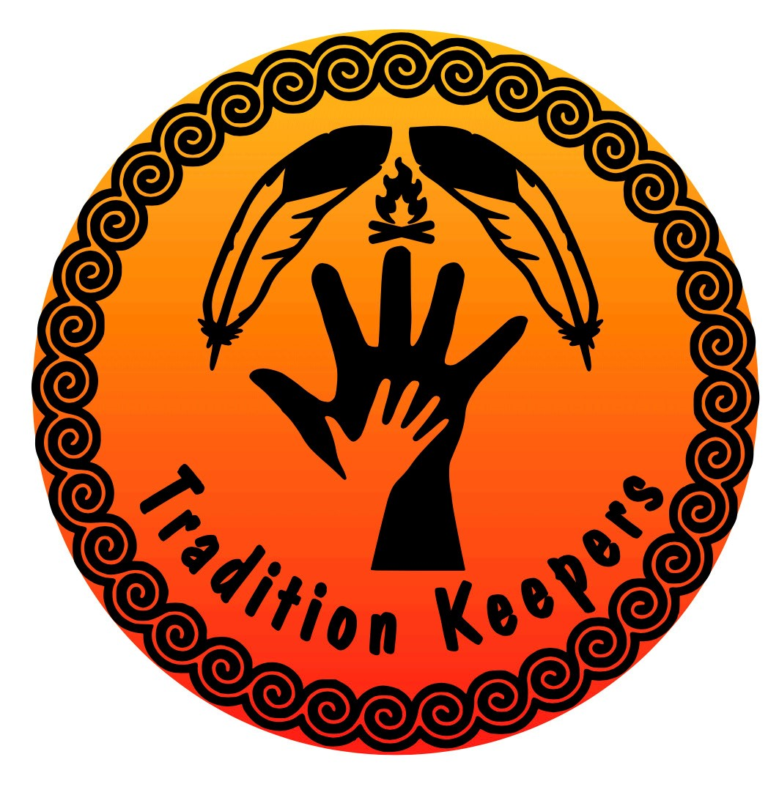
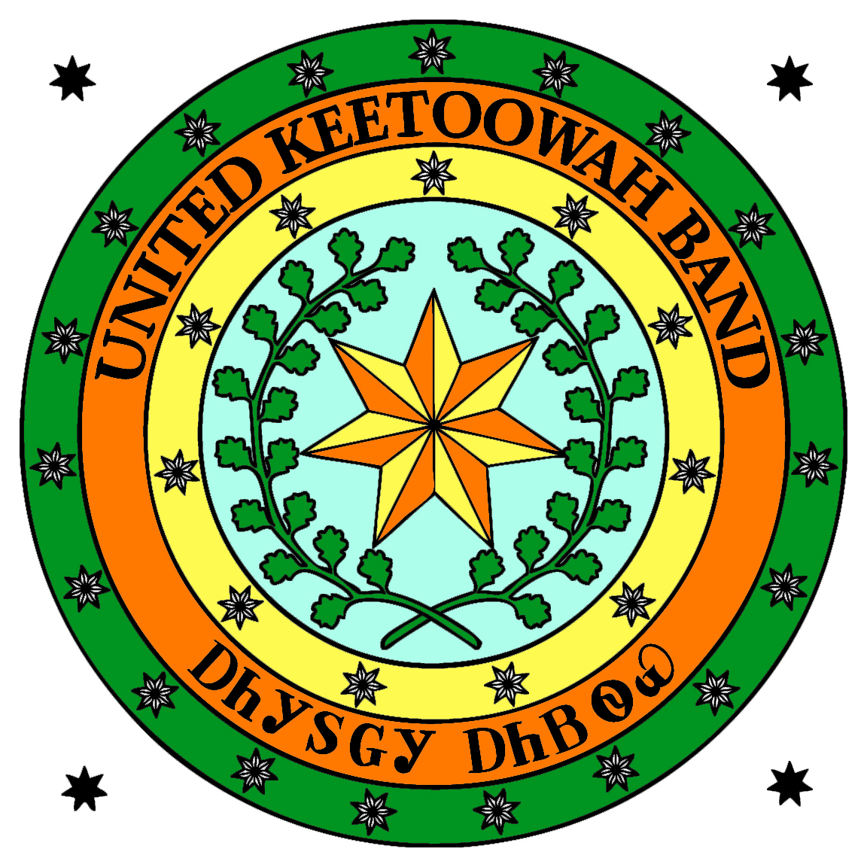

John Hair Cultural Center & Museum
2025 Tradition Keeper Nomination Form

(Two 2024 Tradition Keepers will be chosen: one woman and one man, if qualified man and woman are nominated. Qualifications are given below. The winners will receive an Award of $250.00 each.)
A nominee must be at least 35 years old and an exclusive UKB member for at least 5 years. Please provide the following information for the person you are nominating:
Name of Nominee: _______________________________________Date of Birth__________________________
Address:__________________________________City:______________________State:_____Zip:____________
Phone Number:____________________________Email:______________________________________________
Nominee must be exclusive UKB member. Enrollment will be verified. UKB Roll Number:_______________
Please provide information to be included in bio:
What traditional skill does the nominee practice?_____________________________________________
How long has nominee been practicing the traditional skill, talent, art, etc. ________________________
Who taught him/her the traditional skill?___________________________________________________
Are they continuing to pass down their traditional knowledge?___________ If they are, tell us how: ___________________________________________________________________________________________
___________________________________________________________________________________________
What community or district is the nominee from?___________________________________________. You must talk to your nominee and ask if they are willing to share or teach their traditional skills to other tribal members and the public? Is he/she willing to come to TK meetings and participate in TK Activities? Circle: Yes or No. (You must ask the nominee to verify this answer.) Did the person verify the answer? Circle: Yes or No
Your Name:_________________________________________________________________________________
Address:__________________________________City:_____________________State:_____Zip:____________
Phone Number:____________________________Email:_____________________________________________
You must provide a recent photo of the nominee and a photo of the traditional item
If selected as the 2024 UKB Tradition Keeper, will the nominee give as a gift one example of their traditional work (if applicable) to the UKB John Hair Cultural Center & Museum collection? Circle: Yes or No. (You must ask the nominee to verify this answer.) Did the nominee verify this answer? Circle: Yes or No
Mail completed form to: UKB John Hair Museum, Attn: Ernestine Berry, PO Box 746, Tahlequah, OK 74465. Or drop off at: UKB Community Services Building, 18300 West Keetoowah Circle or the John Hair Cultural Center & Museum, 18280 West Keetoowah Circle, Tahlequah, OK, 74464.
DEADLINE for Nominations: On or before Friday, September 3, 2025, at 5:00 p.m. Please be sure to include all requested information and the photos. Late or incomplete entries will not be considered.

