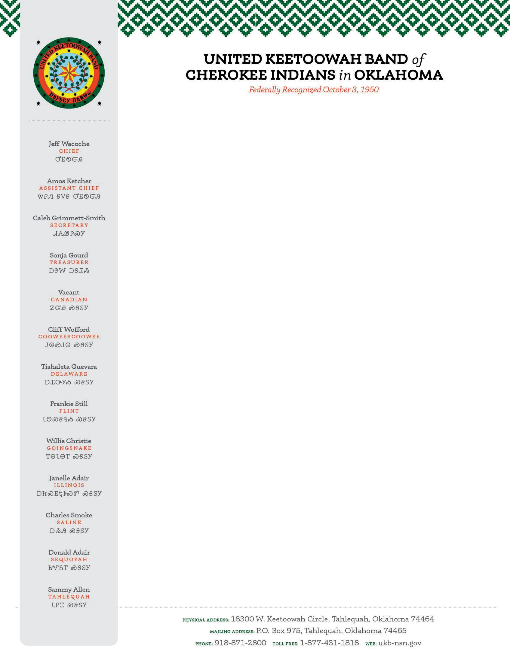

Request
The United Keetoowah Band of Cherokee Indians in Oklahoma is requesting the use of an independent certified public accounting firm to perform a financial and compliance audit in accordance with 2 CFR part 200, the Single Audit Act, Governmental Auditing Standards, and applicable federal, state, or tribal laws and regulations. The audit will cover the tribe’s year ended September 30, 2026, with a tribal option to extend the contract for up to two additional years.
Proposals must be submitted to the Treasurer via email at sgourd@ukb-nsn.gov and Consultant Candice Cushman at candice@cushmancpa.com no later than 5/15/2026, and Tribal Council expects to select a bid on 6/06/2026.

Background
The United Keetoowah Band of Cherokee Indians has more than 14,000 tribal members. Our members reside in several states throughout the U.S., though the majority reside in Oklahoma. We have 76-acres of trust land in Tahlequah that is home to our community services buildings, a childcare center, a museum, a wellness center, an elder center and our stomp grounds. Further information can be found on our website: https://www.ukb-nsn.gov/.

Scope of Work
The tribe desires one audit report; meeting the minimum requirements of the Single Audit Act for submission to the Single Audit Clearinghouse, which should include only the tribe’s Governmental Department (consisting only of the Special Revenue funds).

Proposal Preparation
To expedite the review process, your proposal should include the following information:
- Contact information: Name of proposer’s firm, address, telephone and fax numbers, name of contact person, email, and date of submission.
- Engagement letter: A summary stating the proposer’s understanding of the work to be done and expected time commitment.
- Firm background information: Location of office(s), number of partners, managers, supervisors, seniors, and other professional staff. Describe the range of services provided by your firm, including audit, tax, management, consulting, IT, and other services. State whether the firm has been disciplined by the AICPA or any regulatory or licensing agency in the past five years and detail the circumstances leading to the discipline and the sanctions imposed on the firm.
- Qualifications and Experience of Firm: Describe company experience that is relevant to the proposed services, such as recent experience with other tribal governments, including a list of tribal governments served by your firm in the last three years and types of services rendered to each.

- References: Include references for three tribal governments or enterprises served by the firm in the last three years. The information should include the name of the tribal government and the key contact at the tribe (CFO, chair, treasurer, etc.), contact information (e-mail and phone) for the key contact, the services performed by your firm, and the length of time the reference has been a client of the firm.
- Project Organization and Management: Expected timeline of audit services and number of staff expected to be assigned for the audit.
- Cost Proposal: We are requesting fixed fee proposals including a list of the assumptions upon which the fee may be based, if any. That is, identify any conditions that would cause the firm to request a change in the proposed fee.

Evaluation Criteria
The proposals will be evaluated by tribal council based on the following criteria and point ranges: 0-25 Responsiveness of the proposal in understanding the work to be performed
  - Audit coverage and approach
  - Reasonableness of overall time estimates 0-50 Qualifications and experience of firm
  - Recent experience of firm in auditing Indian tribes and related enterprises
  - Reputation of the firm and satisfaction of the firm’s services as expressed by current clients and references
0-25 Cost of audit 0-100 Total Points

Questions
For questions on this RFP, please contact Treasurer Sonja Gourd at 918.871.2800 ex: 2848 or Candice Cushman at 406.890.8925.

