United Keetoowah Band of Cherokee Indians
TAG AGENCY
P.O. Box 746
Tahlequah, OK 74465

Phone: 918-871-2770 Fax: 918-414-4070
Email: tagagency@ukb-nsn.gov

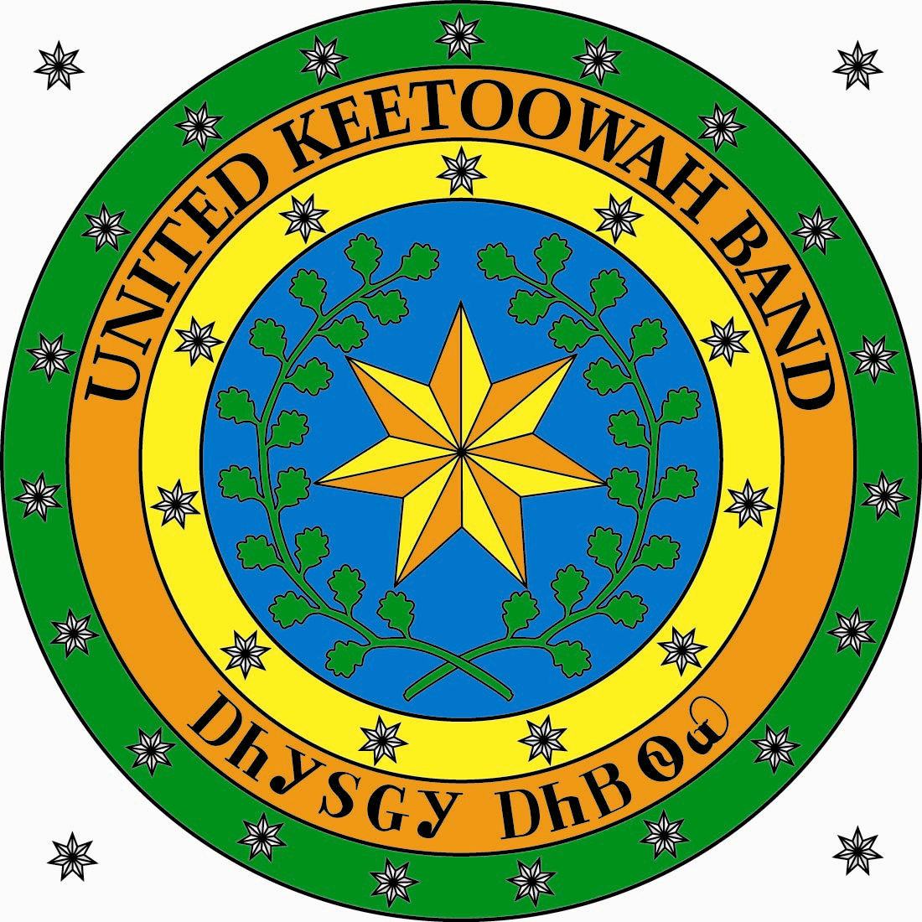

APPLICATION FOR PERSONALIZED TAG
Fee = $25.00 / Non-Refundable

_
____

COMPLETE AFTER PURCHASE OF YOUR CURRENT DECAL FOR LICENSE PLATE. YOUR PERSONALIZED TAG WILL NOT BE RELEASED UNTIL WE RECEIVE THIS FORM FROM YOU. THIS FORM WILL BE RETURNED TO YOU IF NOT PROPERLY COMPLETED***YOUR REGULAR LICENSE PLATE MUST BE CURRENTLY REGISTERED AT ALL TIMES. THE REGULAR LICENSE PLATE SHOULD BE KEPT INSIDE THE VEHICLE AND PRODUCED UPON REQUEST BY LAW ENFORCEMENT. FAILURE TO DO SO MAY BE SUBJECT FOR A FINE. I have read the Red print and fully understand Initial___________

I certify that: I_____________________ will display the Personalized Tag on the vehicle or Motorcycle described as follows:

________ _________ _________ __________ _________
Year Make Model Tag Number Year decal

My TWO choices on the bottom of this form are:

Up to 5 letters with UKB seal or 7 letters without seal for vehicles
5 letters with UKB seal and 6 letters without seal for motorcycles

Mark box if you want UKB seal

1st:________________________ 2nd__________________________

The special personalized license plate number assigned to me will not be transferred to another vehicle or MC without notifying the UKB Tag Agency and furnishing to the Tag Agency a complete description of the vehicle in which it is to be attached and proof of current UKB registration of such vehicle.

Signature: __________________________
Executed Under Penalties of Perjury

Contact Phone(s) # where we can call when Plate comes in: _____________________
__________________

This application is for: (please check) Vehicle ______ Motorcycle ______

____ Original (First Time this personalized tag has been applied for)

____ Replacement (If current personalized tag has been lost, stolen or mutilated)

I hereby make application for the assignment to me a personalized license plate bearing the following numbers and/or letters:

Up to 5 letters with UKB seal or 7 letters without seal for vehicles
5 letters with UKB seal and 6 letters without seal for motorcycles

1st: ________ ________ _________ ________ ________ _______ ______

2nd: ________ ________ _________ ________ ________ _______ ______

The license plate will be attached to and used on the vehicle which will be described on the certificate above to be detached and furnished to the Keetoowah Tag Agency after the purchase of a current decal.

ANY FALSE STATEMENT IN THIS APPLICATION SUBJECTS THE APPLICANT TO PROSECUTION.

PERSONALIZED LICENSE PLATES ARE FOR PASSENGER AUTOMOBILES, PICK-UPS, MOTORCYCLE AND MOTORIZED BICYCLE ONLY.

Signature of Applicant: ___________________________

Date:_________________

NOTICE:
Issuance of any personalized tags and the language or message contained thereon are subject to final approval by the Keetoowah Cherokee Tax Commission. No offensive or foul language or message, or libelous language regarding another individual will be permitted. The Keetoowah Cherokee Tax Commission reserves the right to reject an application that violates these requirements or that they deem inappropriate.

