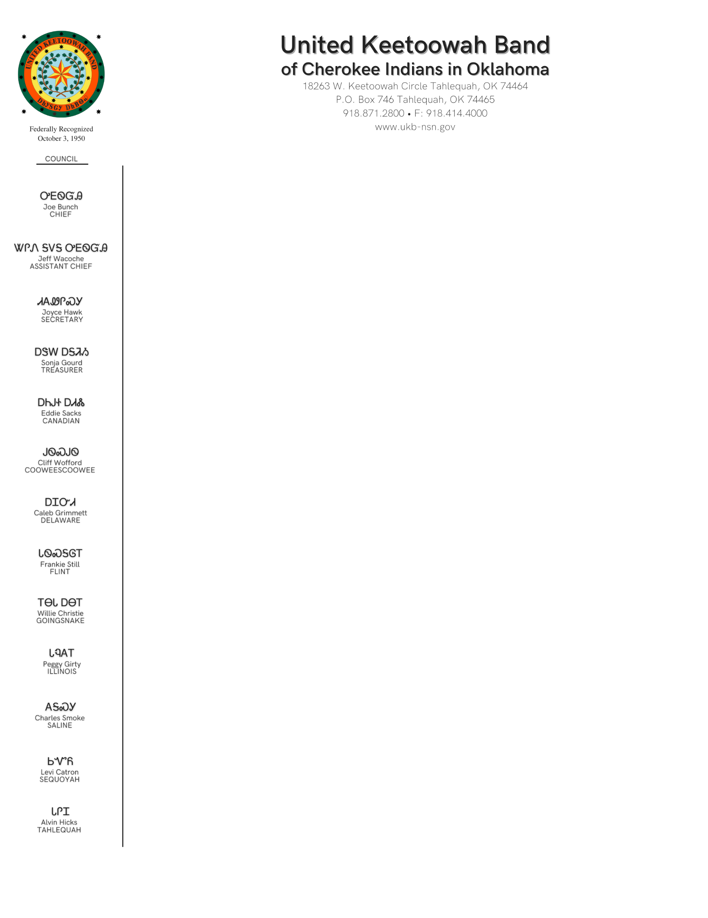

Department of Education Scholarship Volunteer Verification Form
The UKB Education Department reserves the right to accept or deny community service depending on type of service. Please contact the Education Department at 918-871-2796 with questions or for prior approval.
___________________________________________________________
NON-PROFIT ORGANIZATION REPRESENATITVE MUST COMPLETE THIS PORTION

Organization Name:_____________________________________________________

Organization Address:___________________________________________________

Organization City/State/Zip:_______________________________________________

I hereby certify that the listed student has completed ________hours of community service to our organization.

Hours were served between _____________________&_______________________.

Description of Service:____________________________________________________

______________________________________________________________________

______________________________________________________________________

________________________________ ____________________________
Organization Rep. Signature Date

________________________________ ____________________________
Title Phone

STUDENT MUST COMPLETE THIS PORTION

Name:________________________________________SSN:____________________

Semester:_______________________Scholarship Amount:______________________

Student Signature:______________________________________________________

Date:________________________________

